Hands-on :
Spring REST using Spring Boot 3 - Create authentication service that returns JWT

Spring Initializr Configuration :
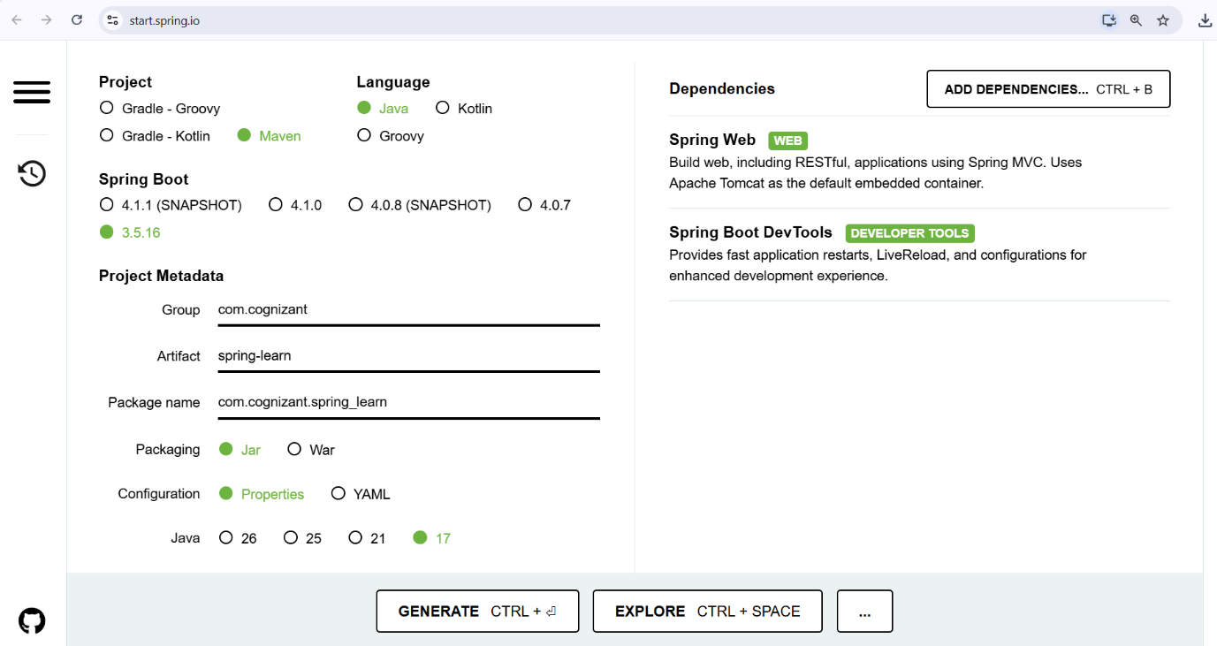

Dependencies :
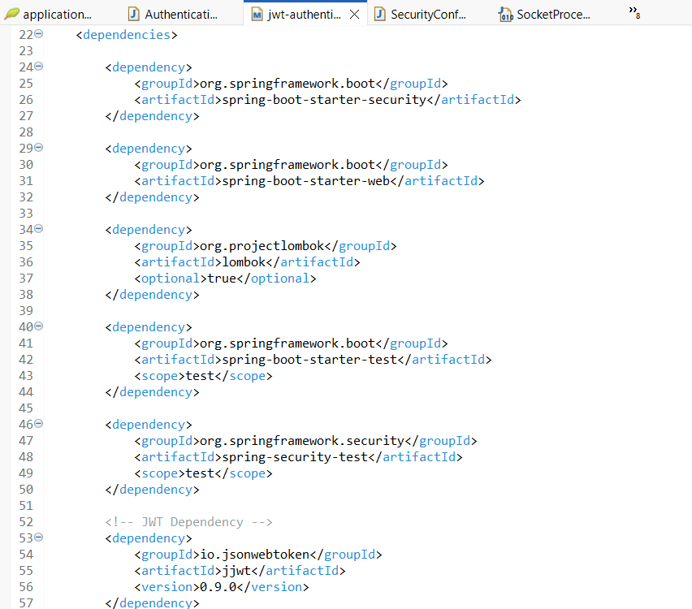
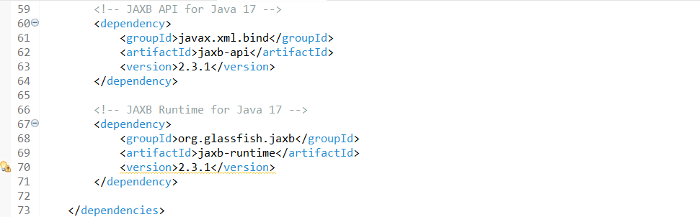

Project Structure :
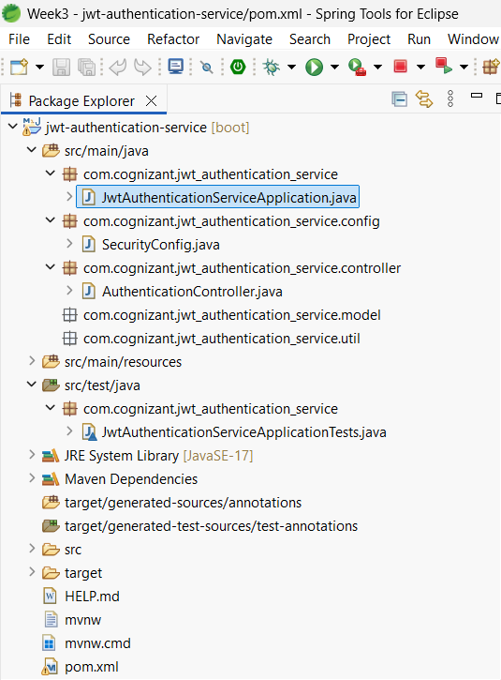

File name : AuthenticationController.java
package com.cognizant.jwt_authentication_service.controller;

import java.util.Base64;
import java.util.Date;
import java.util.HashMap;
import java.util.Map;

import org.springframework.web.bind.annotation.GetMapping;
import org.springframework.web.bind.annotation.RequestHeader;
import org.springframework.web.bind.annotation.RestController;

import io.jsonwebtoken.JwtBuilder;
import io.jsonwebtoken.Jwts;
import io.jsonwebtoken.SignatureAlgorithm;

@RestController
public class AuthenticationController {

@GetMapping("/authenticate")
public Map<String, String> authenticate(@RequestHeader("Authorization") String authHeader) {

System.out.println("Start");
System.out.println("Authorization Header: " + authHeader);

String user = getUser(authHeader);

String token = generateJwt(user);

Map<String, String> map = new HashMap<>();
map.put("token", token);

System.out.println("Authenticated User: " + user);
System.out.println("Generated Token: " + token);

System.out.println("End");

return map;
}

private String getUser(String authHeader) {

String encodedCredentials = authHeader.substring(6);

byte[] decodedBytes = Base64.getDecoder().decode(encodedCredentials);

String credentials = new String(decodedBytes);

System.out.println("Decoded Credentials: " + credentials);

String user = credentials.substring(0, credentials.indexOf(":"));

System.out.println("User: " + user);

return user;
}

private String generateJwt(String user) {

JwtBuilder builder = Jwts.builder();

builder.setSubject(user);

// Token issue time
builder.setIssuedAt(new Date());

// Token expiry time (20 minutes)
builder.setExpiration(new Date(new Date().getTime() + 1200000));

builder.signWith(SignatureAlgorithm.HS256, "secretkey");

String token = builder.compact();

return token;
}
}
Console Output :
Application Started Successfully :
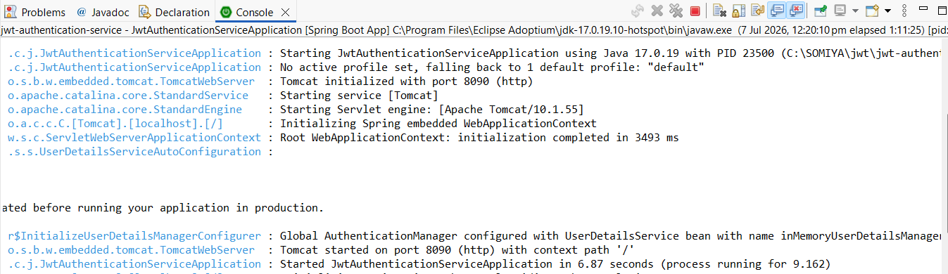

JWT Token Generated :
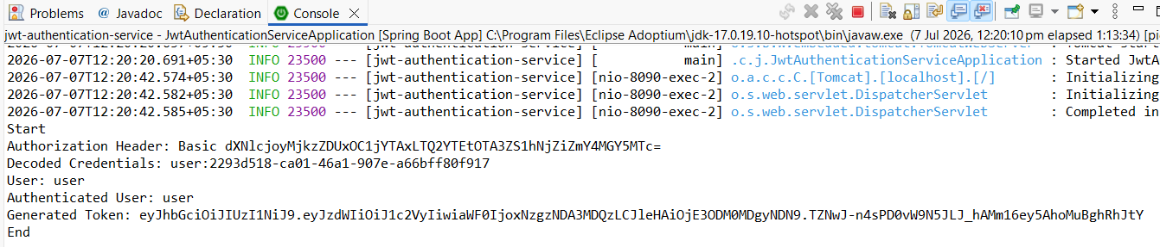

Postman Output :
